CS 499 Module One Assignment Template

Complete this template by replacing the bracketed text with the relevant information.

- Self-Introduction: Address all of the following questions to introduce yourself.

  - How long have you been in the Computer Science program?
I have been in the program for 2 and a half years.

  - What have you learned while in the program? List three of the most important concepts or skills you have learned.
I learned how to work hardware wiring and coding for a raspberry pi. I have learned a few model making concepts with the use of a texture pack database. Also, learning how to make a table with SQL and using queries to find certain information.

  - Discuss the specific skills you aim to demonstrate through your enhancements to reach each of the course outcomes.
I want to focus on rewiring my LED and buttons on my raspberry, then making some code to have the LED track constantly when the setpoint is either below or above the temperature. I would then want to add a way to prevent flickering that would happen if the set point was on the main degree. Then I would like to add a way to log the thermostat data to a MySQL Database to keep track of the temperature like if a room was for some reason not getting cooled down it will show when and what time.

  - How do the specific skills you will demonstrate align with your career plans related to your degree?
I want to work on databases, mostly SQL, which is what I will be demonstrating with tracking the temperature of the room and adding the info into a database.

  - How does this contribute to the specialization you are targeting for your career?
I am on the fence of what I want to get into in the computer science world, I know I want to go into something with my database skills with SQL, but I found that I really loved working with the raspberry pi and might look into some jobs that uses the skills sets of what I learned through the raspberry pi.

- ePortfolio Set Up:

  - Submit a screen capture of your ePortfolio GitHub Pages home page that clearly shows your URL.
    - You already have a repository in GitHub where you uploaded projects in previous courses. Your ePortfolio will reside in GitHub but can link to work at other sites, such as Bitbucket.

  - Use the GitHub Pages link in the Resource section for directions on:
    - How to create your GitHub website and publish code to GitHub Pages
    - Issues, such as adding links to other sites

  - Paste a screenshot of your GitHub Pages home page with your URL clearly showing in the space below.


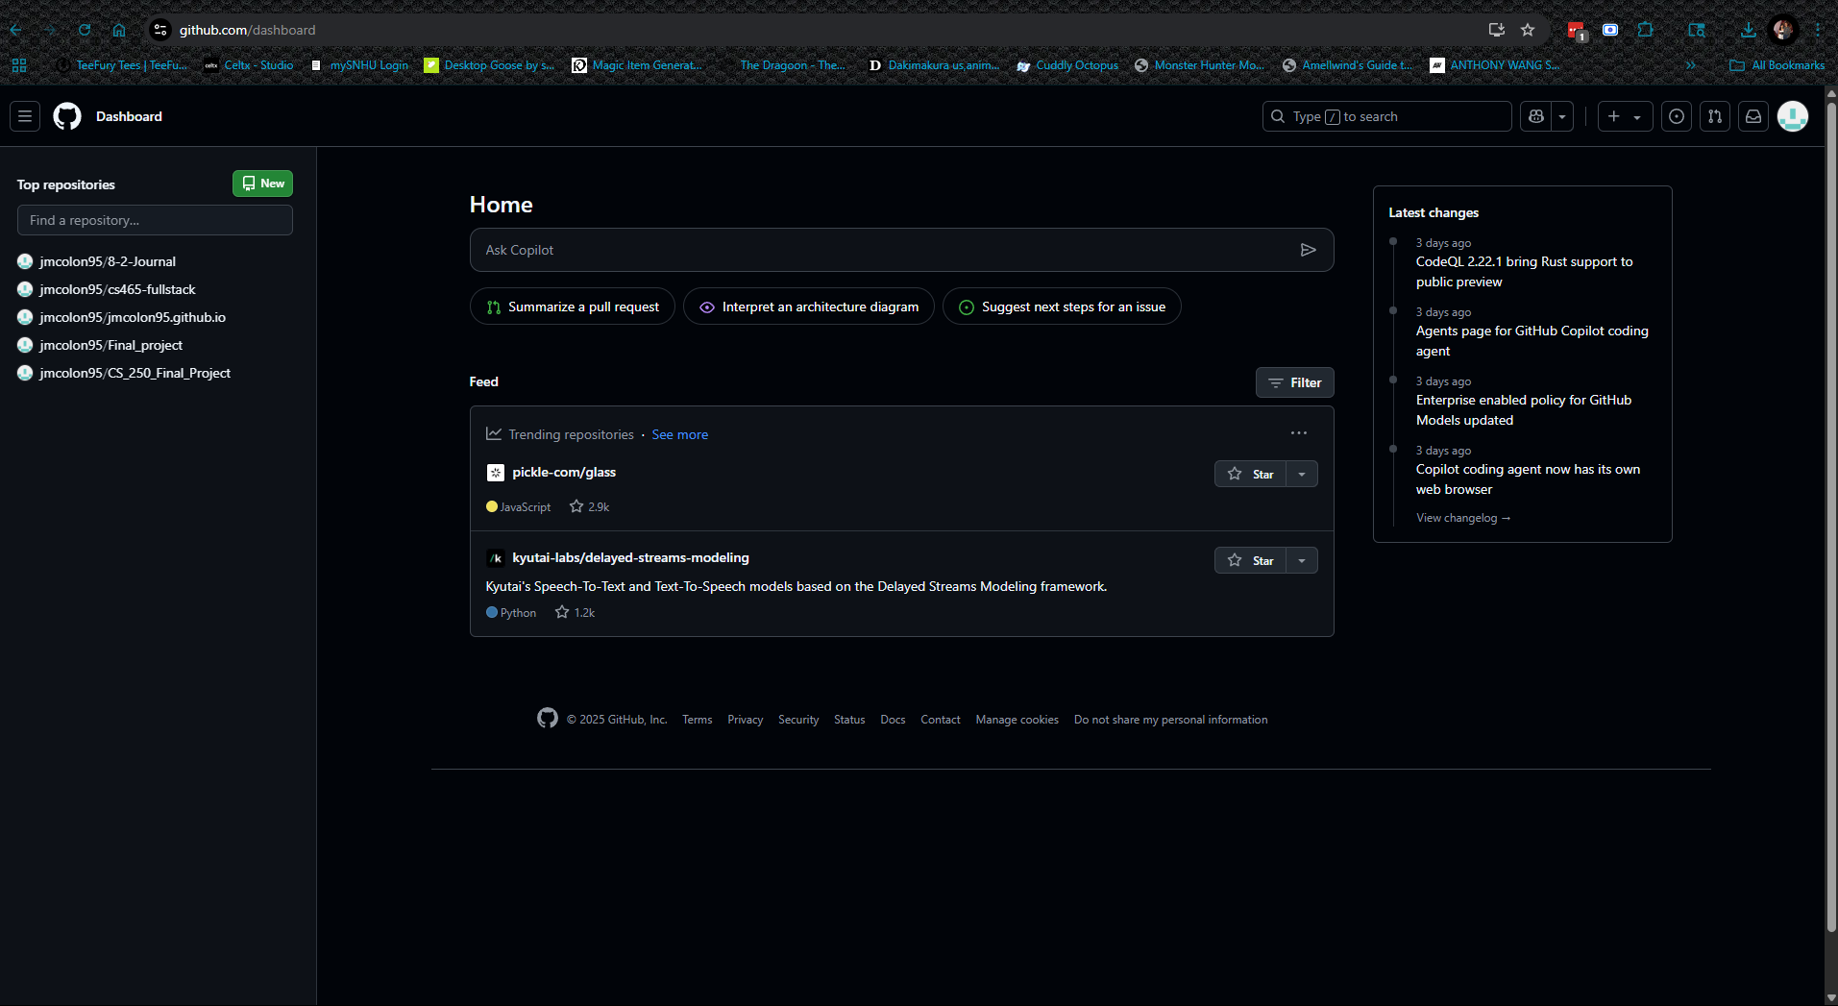
- Enhancement Plan:

  - Category One: Software Engineering and Design
    - Select an artifact that is aligned with the software engineering and design category and explain its origin. Submit a file containing the code for the artifact you choose with your enhancement plan.

The artifact I chose is from the class CS 350. In this class we worked with a raspberry pi and made coding for the different hardware we wired up. I want to improve the temperature final project by making the LED be more automatic in showing when it is hotter or colder than the set point and remove a button to make it only use the setpoint buttons.

Note: Your artifact may be work from the following courses:

- IT 145: Foundation in Application Development
- CS 250: Software Development Lifecycle
- CS 260: Data Structures and Algorithms
- IT 315: Object Oriented Analysis and Design
- CS 320: Software Testing, Automation, and Quality Assurance
- CS 330: Computational Graphics and Visualization
- CS 340: Advanced Programming Concepts
- CS 350: Emerging Systems Architectures and Technologies
- CS 360: Mobile Architecture and Programming
- IT 365: Operating Environments
- IT 380: Cybersecurity and Information Assurance
- CS 405: Secure Coding
- CS 410: Reverse Software engineering
- IT 340: Network and Telecommunication Management
- IT 380: Cybersecurity and Information Assurance

    - Describe a practical, well-illustrated plan for enhancement in alignment with the category, including a pseudocode or flowchart that illustrates the planned enhancement.

I will be improving on the coding of the raspberry pi. What I plan to do is to take out the Cycle button to replace it with a temperatureMachine using:
Def (self)
If
Print Cycling temp state
self.send(cycle)

I will also be separating the LED logic into a class to allow the LED to be removed from the TemperatureMachine. This will allow the LED to light up without a button to check each LED for hot or cold. I might also add dimming which would change the if section. This would look like:
Class tempIndicator:
Def __init__ (self, red pin, blue pin)
Self.red
Self.blue

Def update(self, temp setpoint)
If temp < set:
Red = 1
Blue = 0
Elif temp > set:
Red = 0
Blue = 1
Else:
Red = 0.2
Blue = 0.2

Def Clear(self)
Red off
Blue off

I would then need to update the temperatureMachine class to add the __init__ method:
Def updateLights(Self):
Temp = floor(getFahrenheit())
self.indicator.update(Temp, self.set)

If DEBUG:
print([LED] Temp = {temp}, set = {set})

For this category of enhancement, consider improving a piece of software, transferring a project into a different language, reverse engineering a piece of software for a different operating system, or expanding a project’s complexity. These are just recommendations. Consider being creative and proposing an alternative enhancement to your instructor.

Think about what additions to include to complete the enhancement criteria in this category. Since one example option is to port to a new language, that is the kind of scale that is expected. This does not mean you need to port to a new language but instead have an equivalent scale of enhancement. Underlying expectations of any enhancement include fixing errors, debugging, and cleaning up comments, but these are not enhancements themselves.

    - Explain how the planned enhancement will demonstrate specific skills and align with course outcomes.

      - Identify and describe the specific skills you will demonstrate that align with the course outcome.

This will show the skill of making a system more automated rather than using user input for every part of the system. Rather than having a button to test if the temperature is lower or higher than the setpoint temp, this will do it for the user automatically depending on the setpoint of the user.

      - Select one or more of the course outcomes below that your enhancement will align with.

Demonstrate an ability to use well-founded and innovative techniques, skills, and tools in computing practices for the purpose of implementing computer solutions that deliver value and accomplish industry-specific goals.

Course Outcomes:

- Employ strategies for building collaborative environments that enable diverse audiences to support organizational decision-making in the field of computer science.
- Design, develop, and deliver professional-quality oral, written, and visual communications that are coherent, technically sound, and appropriately adapted to specific audiences and contexts.
- Design and evaluate computing solutions that solve a given problem using algorithmic principles and computer science practices and standards appropriate to its solution while managing the trade-offs involved in design choices.
- Demonstrate an ability to use well-founded and innovative techniques, skills, and tools in computing practices for the purpose of implementing computer solutions that deliver value and accomplish industry-specific goals.
- Develop a security mindset that anticipates adversarial exploits in software architecture and designs to expose potential vulnerabilities, mitigate design flaws, and ensure privacy and enhanced security of data and resources.

  - Category Two: Algorithms and Data Structures

- Select an artifact that is aligned with the algorithms and data structures category and explain its origin. Submit a file containing the code for the artifact you choose with your enhancement plan. You may choose work from the courses listed under Category One.

I will be the same artifact as the first one this time. I will be making sure there is coding to keep the light from flickering from the code I will be adding/editing on my enhancement. I want to make sure that the automated lighting does not flicker any more and the structure is much cleaner.

- Describe a practical, well-illustrated plan for enhancement in alignment with the category, including a pseudocode or flowchart that illustrates the planned enhancement.

The coding would look similar to this:

Def update
Delta = 1
If temp < set - delta:
Red = 1
Blue = 0
Elif temp > set + delta:
Red = 0
Blue = 1
else:
Red = 0.2
Blue = 0.2

I might also integrate a PID Controller for smoother adjustments, but am still researching the way to do that for my code.

For this category of enhancement, consider improving the efficiency of a project or expanding the complexity of the use of data structures and algorithms for your artifact. These are just recommendations. Consider being creative and proposing an alternative enhancement to your instructor. Note: You only need to choose one type of enhancement per category.

Think about what additions to include to complete the enhancement criteria in this category. Since one example option is to port to a new language, that is the kind of scale that is expected. Perhaps you might increase the efficiency and time complexity of an algorithm in an application and detail the logic of the increased time complexity. Remember, you do not need to port to a new language but instead have an equivalent scale of enhancement. Underlying expectations of any enhancement include fixing errors, debugging, and cleaning up comments, but these are not enhancements themselves.

- Explain how the planned enhancement will demonstrate specific skills and align with course outcomes.

  - Identify and describe the specific skills you will demonstrate to align with the course outcome.

I will be showing how to use algorithmic concepts using Hysteresis Logic for the Flickering light, while also trying to test a PID control that is usually used in robotics.

  - Select one or more of the course outcomes listed under Category One that your enhancement will align with.

Design and evaluate computing solutions that solve a given problem using algorithmic principles and computer science practices and standards appropriate to its solution while managing the trade-offs involved in design choices.

Demonstrate an ability to use well-founded and innovative techniques, skills, and tools in computing practices for the purpose of implementing computer solutions that deliver value and accomplish industry-specific goals.

  - Category Three: Databases

    - Select an artifact that is aligned with the databases category and explain its origin. Submit a file containing the code for the artifact you choose with your enhancement plan. You may choose work from the courses listed under Category One.

I will be using the same artifact as the first and second one.

    - Describe a practical, well-illustrated plan for enhancement in alignment with the category, including a pseudocode or flowchart that illustrates the planned enhancement.

I wanna add a way to log the thermostat data to a MySQL Database, for the use of if a room is having troubling AC, it can log when the room is uncomfortable and allow the user to see what time and how uncomfortable it was.
For this code it would look like:
MySQL:

CREATE TABLE temperature_logs (
Id INT Auto_INCREMENT PRIMARY KEY,
Time
Temp
Set
Status (20)
);

Python code:

Import mysql.connect
From date import date

Def log to mysql
Conn = _____
Host
User
Password
Database
)

I would also add a loop where it logs the info every 30 mins or a minute.

For this category of enhancement, consider adding more advanced concepts of MySQL, incorporating data mining, creating a MongoDB interface with HTML/JavaScript, or building a full stack with a different programming language for your artifact. These are just recommendations; consider being creative and proposing an alternative enhancement to your instructor. Note: You only need to choose one type of enhancement per category.

Think about what additions to include to complete the enhancement criteria in this category. Since one example option is to port to a new language, that is the kind of scale that is expected. Perhaps you might increase the efficiency and time complexity of an algorithm in an application and detail the logic of the increased time complexity. Remember, you do not need to port to a new language but instead have an equivalent scale of enhancement. Underlying expectations of any enhancement include fixing errors, debugging, and cleaning up comments, but these are not enhancements themselves.
    - Explain how the planned enhancement will demonstrate specific skills and align with course outcomes.

      - Identify and describe the specific skills you will demonstrate that align with the course outcome.

This will show my skills in creating a database for logging temperature and being able to pull info from the database to keep track of the temperature.

      - Select one or more of the course outcomes listed under Category One that your enhancement will align with.

Design and evaluate computing solutions that solve a given problem using algorithmic principles and computer science practices and standards appropriate to its solution while managing the trade-offs involved in design choices.

Demonstrate an ability to use well-founded and innovative techniques, skills, and tools in computing practices for the purpose of implementing computer solutions that deliver value and accomplish industry-specific goals.

- ePortfolio Overall Skill Set

  - Accurately describe the skill set to be illustrated by the ePortfolio overall.
    - Skills and outcomes planned to be illustrated in the code review

In the code review I will be showing my skills in creating code to track temperature, place input on the setpoint to effect the LED that will react to the placement of the setpoint, while also showing my hardware wiring skills.

    - Skills and outcomes planned to be illustrated in the narratives

In the narratives I will be showing my SQL skills when speaking about making a database for tracking the temperature of the room and logging the information. I will also be showing new skills I will be using for setting up different algorithms.

    - Skills and outcomes planned to be illustrated in the professional self-assessment

Designing modular components, implementing hysteresis logic, planning a design of PID controller and integrating a MySQL database to track temperature.

